UNIT 1 Characteristics of Functions

1. C

2. A No B Yes C Yes D No

3. a. 

b. C

4. 

5. Domain  Range 

6. B

7. A Yes B Yes C No D No

Practice and Problem Solving: C

1. from *x*  0 to *x*  3, from *x*  1 to *x*  3, and from *x*  2 to *x*  3

2. from *x*  0 to *x*  1, from *x*  0 to *x*  2, and from *x*  1 to *x*  2

3. 

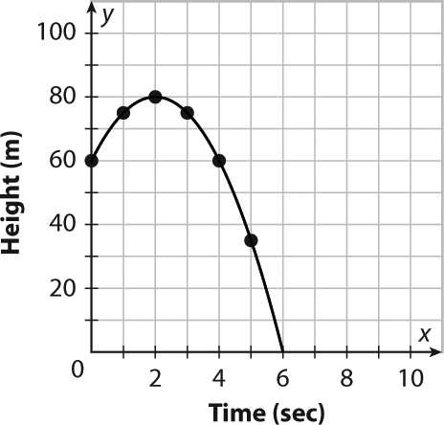

4. 80 m at 2 sec

5. increasing:

6. decreasing:

7. f(7)  45. A negative height does not make sense (it would be below ground). The lowest possible height for the problem situation is 0 m.

8. 6 sec

9. Domain:  Range: 